lab 6

#implement support vecctor machine for classification

import numpy as np

import pandas as pd

import seaborn as sns

import matplotlib.pyplot as plt

from sklearn.datasets import load_iris

from sklearn.svm import SVC

from sklearn.preprocessing import StandardScaler

from sklearn.model_selection import train_test_split

from sklearn.metrics import accuracy_score,confusion_matrix,classification_report

# load dataset

dataset = load_iris()

x=dataset.data

y=dataset.target

# standardization

sc=StandardScaler()

x=sc.fit_transform(x)

# train test split

x_train,x_test,y_train,y_test=train_test_split(x,y,test_size=0.2,random_state=0)

# create and train svc

svc=SVC(kernel='rbf',C=1.0,gamma='scale')#Radaial bias

svc.fit(x_train,y_train)

# predict

y_pred=svc.predict(x_test)

# evaluation

print(accuracy_score(y_test,y_pred))

print(confusion_matrix(y_test,y_pred))

print(classification_report(y_test,y_pred))

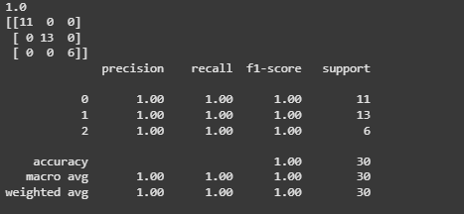

# conhfusion matrix using heatmap

plt.figure(figsize=(4,2))

sns.heatmap(confusion_matrix(y_test,y_pred),annot=True)

plt.title('Confusion Matrix using svm')

plt.xlabel('Predicted')

plt.ylabel('Truth')

